17 What fall has a patio from point C to point A?
Use Pythagoras to find the length of the diagonal 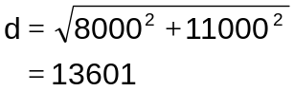
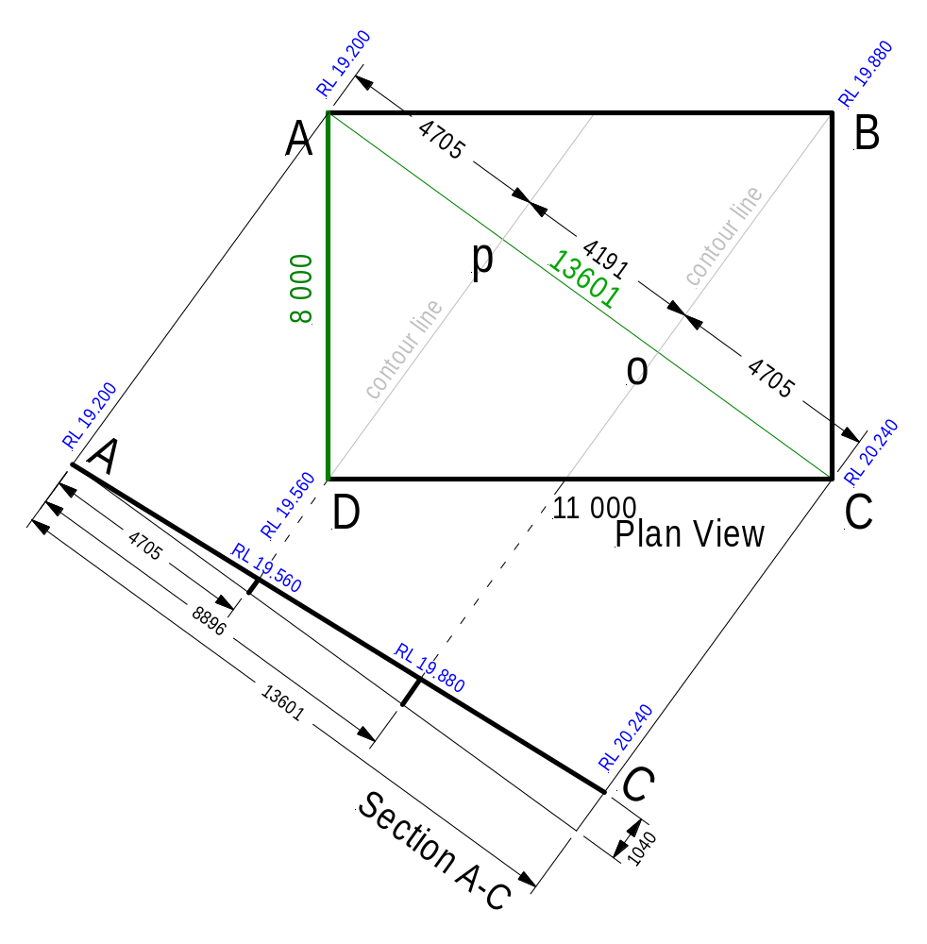N ow we use similar triangles to find the required information.

Triangle BCo = ADp
Length of Line 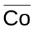 Distance 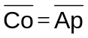
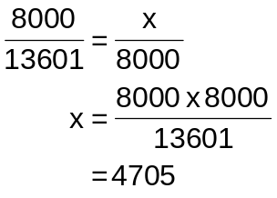

These distances are
perpendicular from line AC
to corner D and B respectively,
Therefore distance from point A to p = 4705, from A to o = 8896

The rise from A to C is a straight line from point A (RL = 19.200) to point B (RL= 20.240)
The difference between point A and Point B is 20.240 – 19.200 = 1040

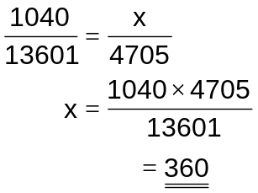 and 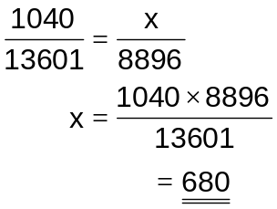

RL at D 19.200 + 0.360 = 19.560 and RL at B 19.200 + 0.680 = 19.880

